**INSTALL DOT NET FRAMEWORK 3.5 FEATURE ROLE**

Open Add Roles and features wizard in server manager and click Next

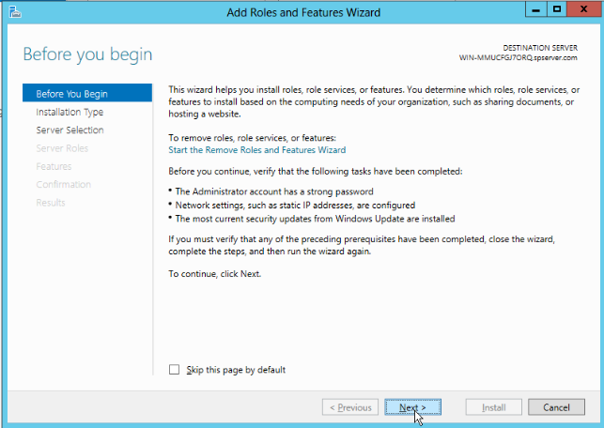

Click the Next option

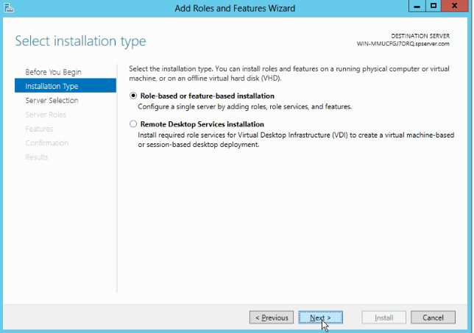

Click Next option

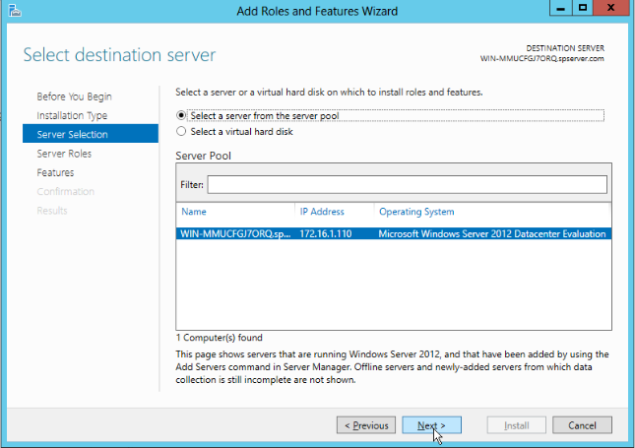

Click the Next Option

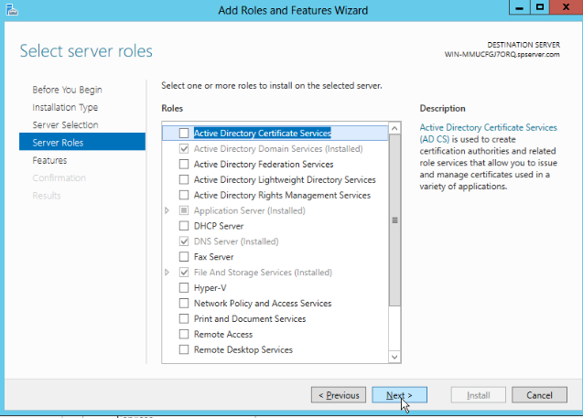

Select the .NET Framework 3.5 features

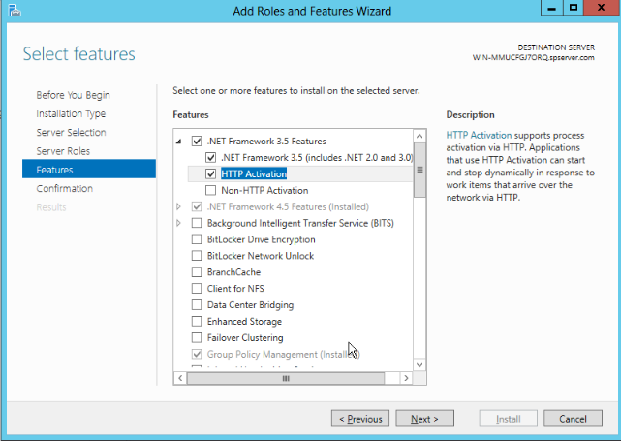

Now click the specify an alternative source path

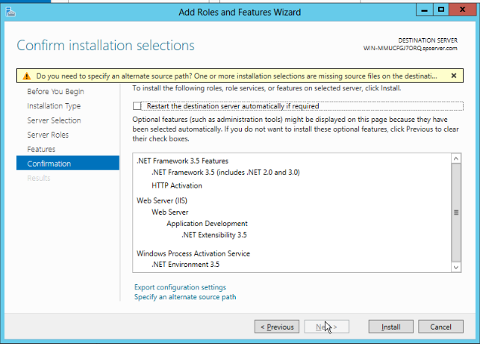

Insert the operating system dvd and enter the path is E:\sources\sxs\ (E is dvd drive letter) and click ok

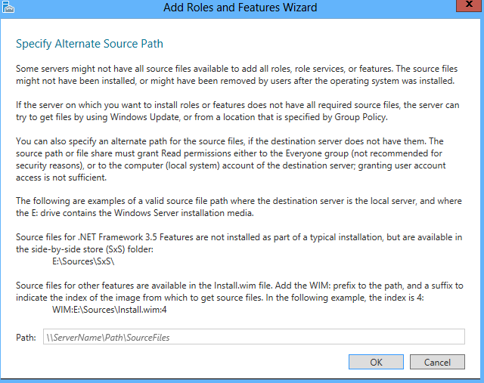

Click the install option

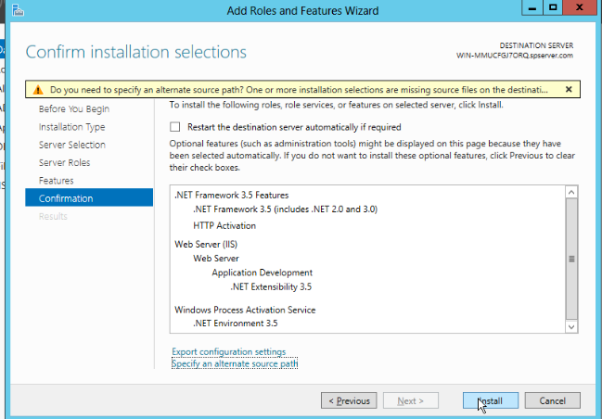

Click the close option

